JAVA PROGRAMMING

CONCURRENT TICKET BOOKING SYSTEM
Proposed Java-Based Solution for Avoiding Double Booking Problem while Concurrent Request for a Ticket
NAME | P ROHINI
REG NO | 192524147
LANGUAGE | Java
DATABASE | SQLite using JDBC

PROBLEM STATEMENT
A ticketing system may receive numerous booking requests for the same seat within a span of few milliseconds. If the booking operation is not thread-safe, multiple customers may book the same seat. This creates double bookings, which result in refunds. Thus, the proposed Java system will model the domain of the booking, manage the seats, perform persistence to a database, and provide concurrency control so that the seats cannot be booked by more than one customer.
AIM
To design a Java-based ticket booking system that avoids double booking, performs booking and payment transaction in a safe manner, and persists the booking record in relational database.
OBJECTIVES
- Use Object-Oriented Programming (OOP) concepts with Show, Customer, Booking, Payment and a Seat class hierarchy.
- Manage seats using Java Collection classes and Generics.
- Implement concurrency booking request through Java threads.
- Ensure the protection of seat checking and booking process through synchronization/locking.
- Use checked exceptions for invalid seat numbers, unavailability of seats, payment failure, and timeout.
- Save successfully booked seat through JDBC and PreparedStatement.
- Include functionality of cancellation, re-stocking of seats, and history of bookings of customers.
TOOLS AND TECHNOLOGIES
- Visual Studio Code - Development and Execution of Java source code.
- JDK 26 - Compilation & Execution
- SQLite - Database which is used for storing booking records.
- SQLite JDBC Driver - JDBC connection between Java and SQLite
- Java Collections Framework - Map/List based inventory and history.
- Java Threads/Synchronization/Locks – booking management in parallel.
- Java Input/output – audit/logging of transactions.
- Git – version control.
PROJECT STRUCTURE
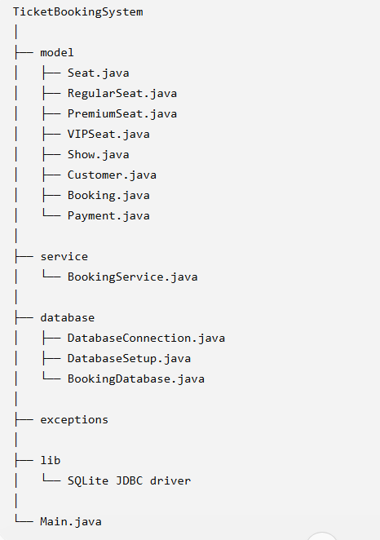
PROCEDURE
- Set up the Java project in VS Code with the model, service, database and exceptions packages.
- Create the base Seat class and Seat subclasses for Regular, Premium and VIP Seats.
- Create classes for Show, Customer, Booking and Payment.
- Use a Map to maintain seats and implement lookup by seat number.
- Establish the SQLite connection and bookings table through JDBC.
- Develop the functionality for booking validation and payment.
- Perform insertion of bookings through PreparedStatement.
- Make a menu-based interface for booking, viewing bookings, and exiting.
- Handle checked exceptions, transaction rollback, and cancellation.
- Use concurrent Java threads and test overlapping bookings for seats.
- Test both synchronized and unsynchronized solutions and ensure that the fixed solution does not have double-bookings.
- Log all successful transactions to a file and query booking records of customers.
OOP DESIGN
- Inheritance: Seat is extended by RegularSeat, PremiumSeat and VIPSeat.
- Polymorphism: different seat types may have their own way to calculate price.
- Encapsulation: seat/customer/booking information is accessible via methods not public properties.
- Association: Booking links a customer, show and seat.
- Service layer: BookingService includes booking logic.

DATABASE / JDBC IMPLEMENTATION
SQLite is employed to implement the relational database of this system. The database connection is created using DatabaseConnection; DatabaseSetup sets up the bookings table, and BookingDatabase gets bookings from the database. PreparedStatement allows using parameterized SQL queries where user inputs are not directly inserted into SQL statements.
Example booking insert:
INSERT INTO bookings (customer_name, seat_number, show_name, payment_status) VALUES (?, ?, ?, ?);
9. BOOKING WORKFLOW
Customer → Choose show → Choose seat → Check seat → Make payment → Confirm seat → Save booking to SQLite → Confirmation
In the case of concurrency implementation, the seat availability check and seat confirmation have to be implemented as an atomic operation. In case of payment failure after temporary seat allocation, the seat is freed.
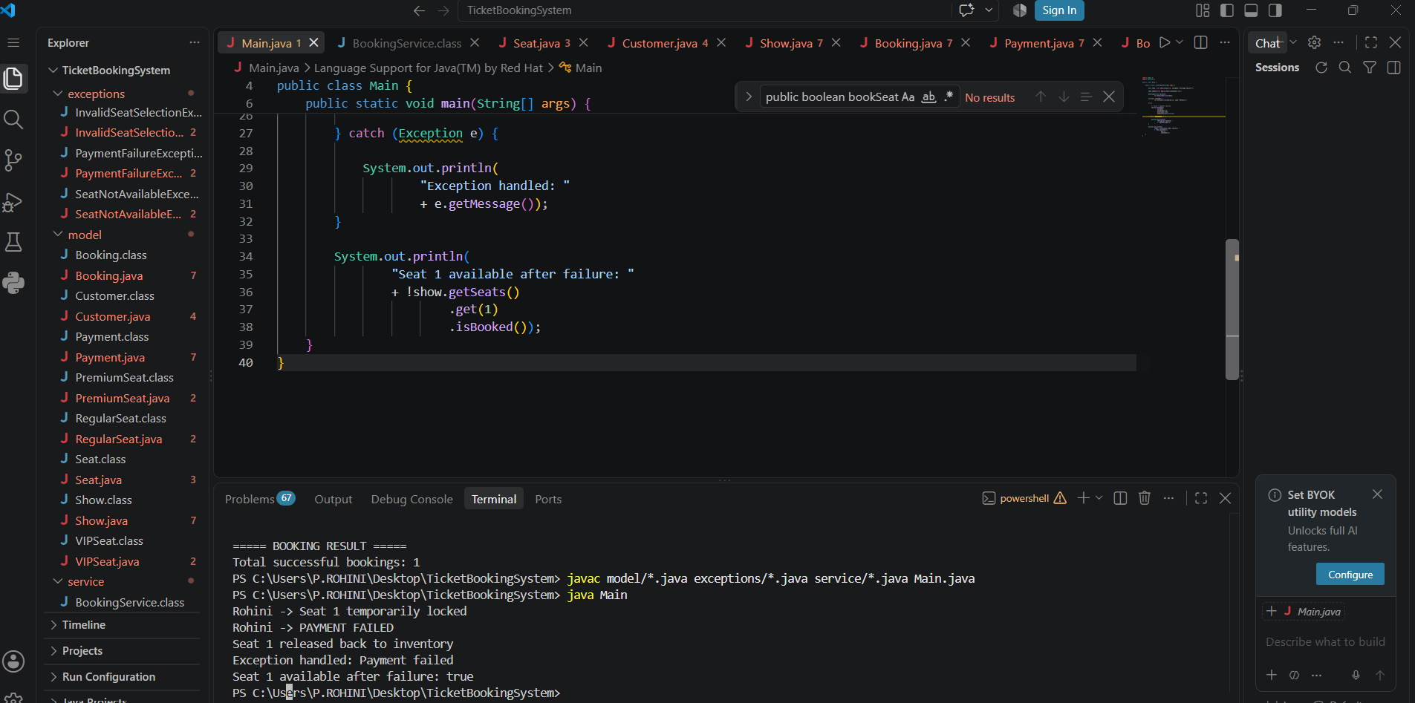
CUSTOM EXCEPTION HANDLING
- SeatNotAvailableException – thrown in case if the chosen seat is already booked.
- InvalidSeatSelectionException – throws when the selected seat doesn’t exist.
- PaymentFailureException – throws when there’s an error in simulated payment process.
- BookingTimeoutException – throws when booking process takes more time than allowed.
CONCURRENCY TEST DESIGN
20 Java threads of customers will be created requesting the seats for the same show simultaneously. There will be 2 steps to run this test: unsynchronized booking process to identify the race condition and then synchronized/locked booking process to secure the critical section. Acceptance criteria – the synchronization step should have a unique booking for each seat.
PAYMENT FAILURE AND ROLLBACK
The fake payment result will be used since the payment gateway is beyond the scope of the project. In case of failed payment, the booking process releases the seat. This way, the seat won’t be locked without a payment.

CANCELLATION AND BOOKING HISTORY
- Cancellations involve deletion or updating of the booked row in the database table.
- The seat that has been cancelled gets added back to the available seats list.
- History of the customer is fetched by using PreparedStatement with parameters.
JAVA I/O AUDIT LOG
Every successful booking, cancellation, failed payments, and errors in booking can be logged to a text file using Java I/O. This helps in maintaining a log of transactions for testing and demonstration purposes.
ACTUAL WORKING OUTPUT RECORDED
The below output was achieved from the Java project:
Table created Bookings successfully! Booking recorded to database! Ticket booking successful! Customer: Rohini Seat: R1 Status: Success
TOOL SETUP EVIDENCE
Asset selection of SQLite JDBC driver for use in this project:
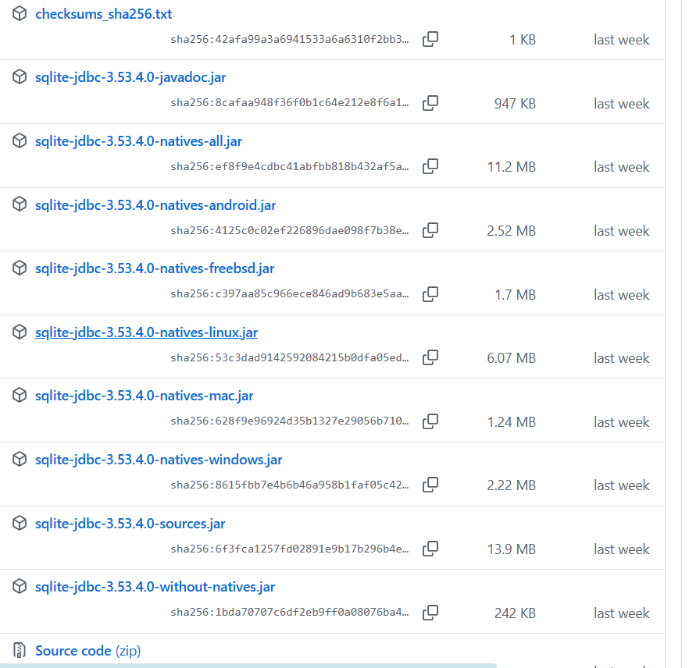
Figure 1. Download/asset selection screen of SQLite JDBC driver.
TEST CASES
TC ID | Scenario | Input | Expected Result | Actual Result | Status
TC01 | Valid booking | R1 | Booking succeeds and is stored | Booking succeeded; saved to database | PASS
TC02 | Invalid seat | X9 | Invalid seat is rejected | Implemented validation | PASS
TC03 | Already booked seat | R1 after first booking | Second booking is rejected | Seat availability check present | PASS
TC04 | Concurrent same-seat requests | 20+ threads | At most one succeeds after synchronization | To be captured in final concurrency run | PENDING
TC05 | Payment failure | Mock failure | Seat is released | To be captured in final rollback run | PENDING
TC06 | Cancellation | Existing booking | Row is removed/updated and seat restored | To be captured in final cancellation run | PENDING
RESULTS AND VALIDATION
This current implementation has been successfully verified for creating the database, booking tickets, booking status, menu functionality and persistence of booking. Results of the acceptance test related to concurrency issues need to be recorded after execution of the 20+ threads test case: unsynchronized test run needs to prove existence of race conditions, whereas synchronized test needs to prove nonexistence of double bookings.
CONCLUSION
Concurrent Ticket Booking System has been developed as a foundation for safe ticket booking in Java. This part of system implementation successfully creates the database, executes booking process, saves payment status and booking with SQLite/JDBC. Final assignment verification will include acceptance test of 20+ threads test case, synchronization, rollback on exception, cancel, history and audit.
REFERENCES
- Documentation of Java SE – concurrency, collection, exceptions, and I/O.
- Documentation of JDBC API – database connectivity and PreparedStatement.
- Documentation of SQLite JDBC Driver – SQLite connectivity from Java.
- Problem statement for CO4 assessment provided.

